THE RAVEN W6
375 Goldhawk Rd, Hammersmith, London W6 0SA Tel: 020 8748 6977
email: INFO@THERAVENW6.COM

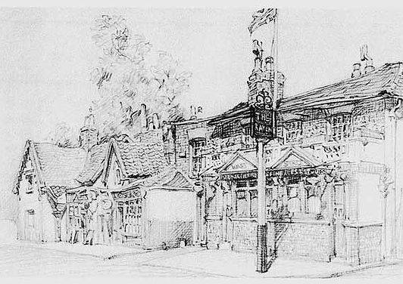

Function Menu Pack

www.theravenw6.com

THE RAVEN W6
375 Goldhawk Rd, Hammersmith, London W6 0SA
Tel: 020 8748 6977 email: INFO@THERAVENW6.COM

Buffet Menu 1

Choose from the Selection of freshly cut sandwiches OR the Bruschetta Options

Roast Ham & Mustard (G/D/MU/S)
Cheese & Sliced Tomato (G/D/MU/S) | Chicken & Pesto Crostini (G/D/S)
Tuna Mayonnaise (G/D/E/F/S) | Tomato, Red Onion & Basil Bruschetta (G/S)
Egg Mayonnaise (G/D/E/S) | Mushroom & Cream Crostini (G/D/S/SU)

Roast Turkey & Mayonnaise (G/D/E/S)

Monterey Jack Cheese & Onion Goujons (G)
Honey & Mustard Cocktail Sausages (G/Su/Mu)
Mini Vegetable Spring Rolls (G/S)
Beer Battered Onion Rings (G/MU)
Sweet Potato Curry Bites (G/MU)

£11.00 per Head

Celery (C) | Gluten (G) | Crustaceans (CR) | Egg (E) | Fish (F) | Lupin (L) | Milk (D)
Molluscs (M) | Nuts (N) | Peanuts (PN) | Sesame(Ses) | Soya (S) | Sulphates (SU) | Mustard (MU)

THE RAVEN W6
375 Goldhawk Rd, Hammersmith, London W6 0SA
Tel: 020 8748 6977 email: INFO@THERAVENW6.COM
Buffet Menu 2

Platters of Cold Sliced Ham & Roasted Turkey Breast

Brandied Chicken Liver & Bacon Pâté (D, SU)
& French Stick with Butter (D,G)

Sliced Smoked Salmon with Lemon Juice (F)

Homemade Vegetable Quiches (G/D/E)
Breast of Cajun Chicken Strips
Mini Pork Pies with Branston Pickle (G)

Potato Salad (E), Spicy Cous Cous (G/C),
Goats Cheese Strawberry & Balsamic Salad (D/SU), Coleslaw (E), Sliced Cucumber & Tomato

£16 per head

Celery (C) | Gluten (G) | Crustaceans (CR) | Egg (E) | Fish (F) | Lupin (L) | Milk (D)
Molluscs (M) | Nuts (N) | Peanuts (PN) | Sesame(Ses) | Soya (S) | Sulphates (SU) | Mustard (MU)

THE RAVEN W6
375 Goldhawk Rd, Hammersmith, London W6 0SA
Tel: 020 8748 6977email: INFO@THERAVENW6.COM

Buffet Menu 3

Choose from the Selection of freshly cut sandwiches
OR the Bruschetta option

Roast Ham & Mustard (G/D/MU/S)
Cheese & Sliced Tomato (G/D/MU/S) | Chicken & Pesto Crostini (G/D/S)
Tuna Mayonnaise (G/D/E/F/S) | Tomato, Red Onion & Basil Bruschetta (G/S)
Egg Mayonnaise (G/D/E/S) | Mushroom & Cream Crostini (G/D/S/SU)

Roast Turkey & Mayonnaise (G/D/E/S)

Homemade Vegetable Quiches (G/D/E)
Sweet Potato Curry Bites (G/MU)
Breast of Cajun Chicken Strips
Mini Pork Pies with Branston Pickle (G)
Mini Vegetable Spring Rolls (G/S)

£12.50 per Head

Celery (C) | Gluten (G) | Crustaceans (CR) | Egg (E) | Fish (F) | Lupin (L) | Milk (D)
Molluscs (M) | Nuts (N) | Peanuts (PN) | Sesame(Ses) | Soya (S) | Sulphates (SU) | Mustard (MU)

THE RAVEN W6
375 Goldhawk Rd, Hammersmith, London W6 0SA
Tel: 020 8748 6977 email: INFO@THERAVENW6.COM

Bruschetta Menu £1.25 per Item

Goat’s Cheese Mouse on Toasted Bread (D/G/S)
~
Bruschetta of Tomatoes, Olives Red Onion Garlic & Olive Oil (G/S)
~
Smoked Salmon & Soft Cheese Rolls with Chives (F/G/D/S)
~
Broad Bean, Artichoke, Feta & Basil on Bruschetta (G/D/S)
~
Smoked Mackerel & Dill Pate on Crusty Bread (G/F/S)
~
Mushroom & Cream Crostini (G/D/S/SU)
~
Tapenade of Mixed Olives, Garlic & Parsley on Chunky Croutons (G/S)
~
Chicken, Bacon & Liver Pate on Warm Bread & Rocket (G/S)
~
Buffalo Mozzarella, Red Onion & Avocado (G/D/S)
~
Avocado, Red Onion, Chilli & Lime & Coriander on Melba Toast (G/S)
~
Chicken & Pesto Crostini (G/D/S)
~
Mushroom & Stilton Vol Au Vent (G/D/S)
~

Red Pepper & Mozzarella Crostini (G/D/S)

Celery (C) | Gluten (G) | Crustaceans (CR) | Egg (E) | Fish (F) | Lupin (L) | Milk (D)
Molluscs (M) | Nuts (N) | Peanuts (PN) | Sesame(Ses) | Soya (S) | Sulphates (SU) | Mustard (MU)

THE RAVEN W6
375 Goldhawk Rd, Hammersmith, London W6 0SA
Tel: 020 8748 6977 email: INFO@THERAVENW6.COM

BBQ Menu 1

4-5oz Homemade Beef Burger (G/E/F)
Brook Farm Cumberland Sausage (G/SU)
Marinated Blackened Style Cajun Chicken Breast

******
Plus the following,

Burger Bap (G/S), Fried Onion, Potato Salad (E), Coleslaw (E),
Spicy Cous Cous (G/C), Mixed Leaf,
Sliced Cucumber, Tomato & Salad Dressing (MU)

******
Vegetarian Option

Mediterranean Vegetable Kebabs
Chickpea & Coriander Burger
Vegetarian Sausage (G/SU)

£12.50 per Head

Celery (C) | Gluten (G) | Crustaceans (CR) | Egg (E) | Fish (F) | Lupin (L) | Milk (D)
Molluscs (M) | Nuts (N) | Peanuts (PN) | Sesame(Ses) | Soya (S) | Sulphates (SU) | Mustard (MU)

THE RAVEN W6
375 Goldhawk Rd, Hammersmith, London W6 0SA
Tel: 020 8748 6977 email: INFO@THERAVENW6.COM

BBQ Menu 2

4-5oz Homemade Beef Burger (G/E/F)
Brook Farm Cumberland Sausage (G/SU)
Marinated Blackened Style Cajun Chicken Breast
Slow Roasted BBQ Pulled Pork (SU)

******
Plus the following,

Burger Bap (G/S), Fried Onion, Potato Salad (E), Coleslaw (E),
Spicy Cous Cous (G/C), Mixed Leaf,
Sliced Cucumber, Tomato & Salad Dressing (MU)

******
Vegetarian Option

Mediterranean Vegetable Kebabs
Grilled Halloumi Slices (D)
Chickpea & Coriander Burger
Vegetarian Sausage (G/SU)

£14.50 per Head
Celery (C) | Gluten (G) | Crustaceans (CR) | Egg (E) | Fish (F) | Lupin (L) | Milk (D)
Molluscs (M) | Nuts (N) | Peanuts (PN) | Sesame(Ses) | Soya (S) | Sulphates (SU) | Mustard (MU)

THE RAVEN W6
375 Goldhawk Rd, Hammersmith, London W6 0SA
Tel: 020 8748 6977 email: INFO@THERAVENW6.COM

Hog Roast Prices
Up To 100 people £850.00
Up to 125 people £950.00

This includes:
The provision of the Pig,
The hire of equipment, cooking and carving of the Pig.
Apple Sauce & Sage & Onion Stuffing (G/D)

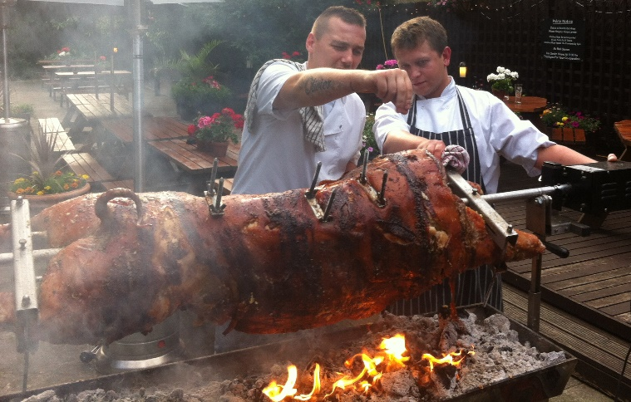

Potatoes & Salad @ £3.00 per person

Brioche Bun (G/S), Fried Onion, Potato Salad (E), Coleslaw (E),
Spicy Cous Cous (G/C), Mixed Leaf,
Sliced Cucumber, Tomato

The Hog's head is removed before cooking
Celery (C) | Gluten (G) | Crustaceans (CR) | Egg (E) | Fish (F) | Lupin (L) | Milk (D)
Molluscs (M) | Nuts (N) | Peanuts (PN) | Sesame(Ses) | Soya (S) | Sulphates (SU) | Mustard (MU)

